**Exercise 1: Setting Up Junit**

**Calculator.java**

package com.example;

public class Calculator {

public int add(int a, int b) {

return a + b;

}

}

**CalculatorTest.java**

package com.example;

import static org.junit.Assert.assertEquals;

import org.junit.Test;

public class CalculatorTest {

@Test

public void testAdd() {

Calculator calc = new Calculator();

assertEquals(5, calc.add(2, 3));

}

}

**Output:**

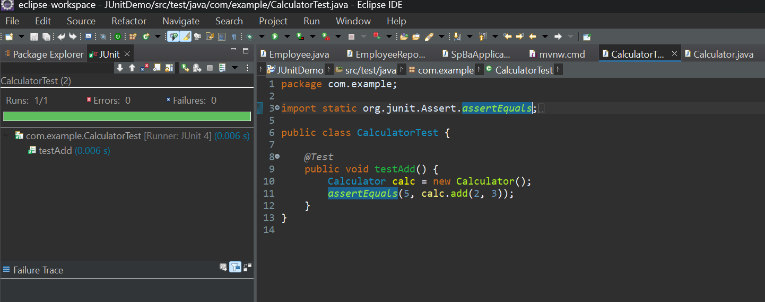

**Exercise 3: Assertions in Junit**

**AssertionsTest.java**

package com.example;

import static org.junit.Assert.*;

import org.junit.Test;

public class AssertionsTest {

*@Test*

public void testAssertions() {

// Assert equals

*assertEquals*(5, 2 + 3);

// Assert true

*assertTrue*(5 > 3);

// Assert false

*assertFalse*(5 < 3);

// Assert null

*assertNull*(null);

// Assert not null

*assertNotNull*(new Object());

}

}

**Output:**

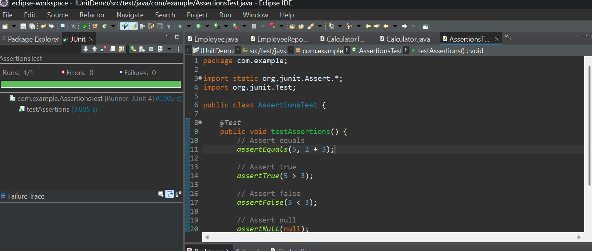

**Exercise 4: Arrange-Act-Assert (AAA) Pattern, Test Fixtures, Setup and Teardown Methods in Junit**

**CalculatorAAATest.java**

package com.example;

import static org.junit.Assert.*;

import org.junit.Before;

import org.junit.After;

import org.junit.Test;

public class CalculatorAAATest {

private Calculator calc;

*@Before*

public void setUp() {

calc = new Calculator();

System.*out*.println("Setup: Calculator created");

}

*@After*

public void tearDown() {

System.*out*.println("Teardown: Test completed");

}

*@Test*

public void testAdd() {

int result = calc.add(2, 3);

*assertEquals*(5, result);

}

}

**Output:**

